**BUG 01**

|  |  |
| --- | --- |
| **Bug number** | ***01*** |
| **Tester Name** | ***Agustina Monti*** |
| **Title** | ***Duplicated Testimonial carousel dots*** |
| **OS/Device** | ***Windows 11 / website - mobile*** |
| **Browser** | ***Chrome (Version 114.0.5735.110)*** |
| **Priority/Severity** | ***Medium/Low*** |

**Description**

In the Testimonials section of the Services page, there is a bug where the carousel dots, indicating the current testimonial being displayed, are duplicated to the right of the original dots. The duplicated dots appear in a smaller size compared to the original ones. However, clicking on any of these duplicate dots allows you to navigate between the testimonials.

**Steps to reproduce:**

1. Open the page <https://inhouse.decemberlabs.com/>
2. Navigate to the Testimonials section of the Services page.
3. Observe the carousel dots representing the testimonials.

**Expected result:**

The carousel dots should be displayed as a single set, aligned correctly and in the same size. Clicking on a dot should navigate to the corresponding testimonial.

**Actual result:**

The carousel dots are duplicated at the right of the original set and the duplicated dots are smaller in size compared to the original ones. Despite the duplication, clicking on any of the dots correctly navigates between the testimonials.

**Evidences:**

**Screenshot:**

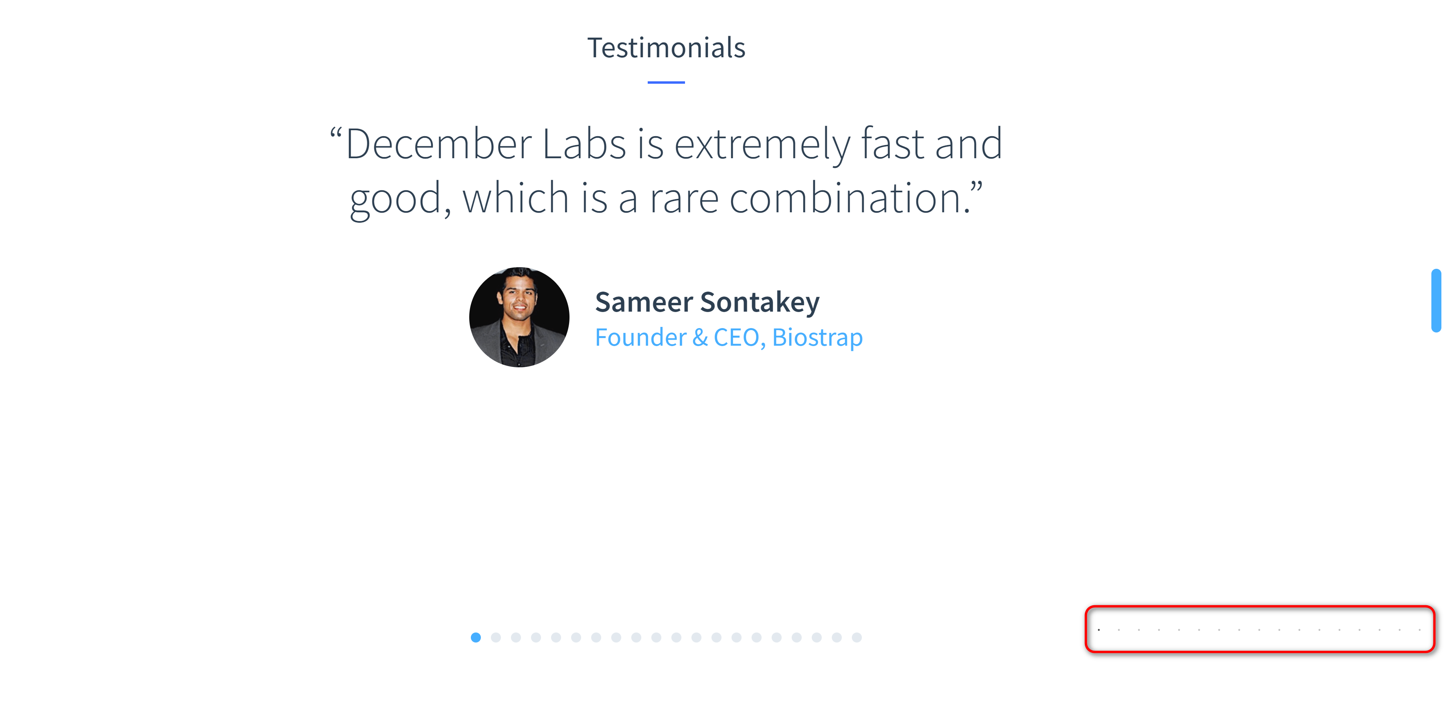

**BUG 02**

|  |  |
| --- | --- |
| **Bug number** | ***02*** |
| **Tester Name** | ***Agustina Monti*** |
| **Title** | ***Incomplete/invalid Email and inconsistent success message in Newsletter Sign-Up form*** |
| **OS/Device** | ***Windows 11 / website - mobile*** |
| **Browser** | ***Chrome (Version 114.0.5735.110)*** |
| **Priority/Severity** | ***High/Medium*** |

**Description**

The Newsletter Sign-Up form has several bugs that affect the user experience and data validation.

Firstly, the form allows submission with missing fields. Secondly, when the email field is filled with invalid data, specifically without the "@" symbol, the form still allows submission. Additionally, upon clicking the "Send" button, a success page is displayed indicating a successful submission. However, a new tab opens displaying a form with an error message indicating that the Email field is invalid.

**Steps to reproduce:**

1. Open the page <https://inhouse.decemberlabs.com/>
2. Navigate to the “News and things that inspire us”section of the Blog page.
3. Click on the Sign Up button.
4. Submit the form with the required Email field empty or an invalid email (without the "@" symbol).
5. Observe the displayed success page.
6. Notice the opening of a new tab with an error message indicating that the Email field is invalid.

**Expected result:**

* The form should not allow submission if any required field is incomplete.
* The form should properly validate the email field and require a valid email address format.
* Upon clicking "Send," the success page should only be displayed if the form data is valid.
* There should be no opening of a new tab showing an error message after the success page.

**Actual result:**

The form allows submission with missing required fields. An invalid email without the "@" symbol is accepted. A success page is displayed initially, indicating a successful submission.

However, a new tab opens shortly after, showing an error message indicating that the Email field is invalid.

**Evidences:**

**Video:**



**Screenshots:**

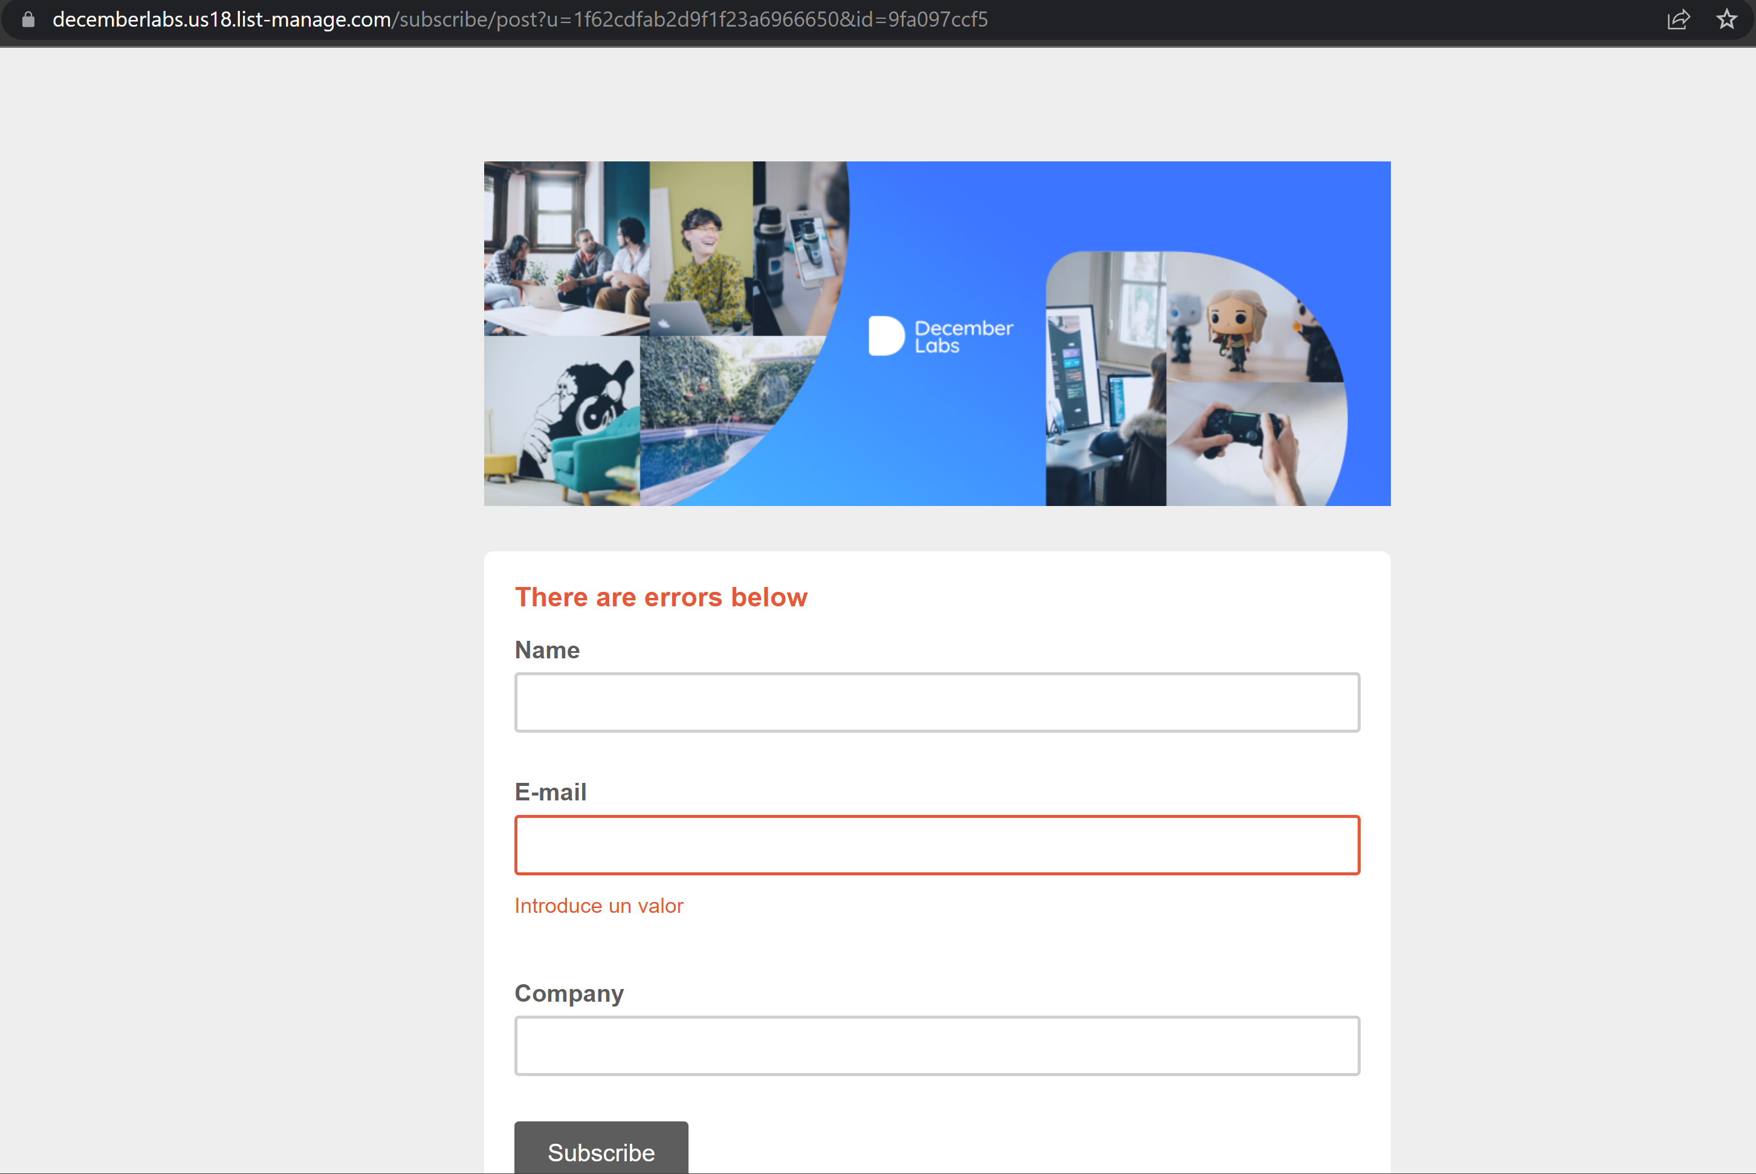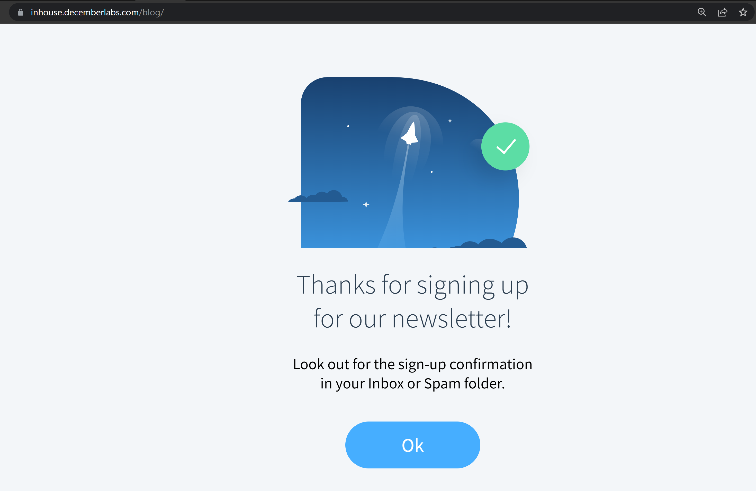

**BUG 03**

|  |  |
| --- | --- |
| **Bug number** | ***03*** |
| **Tester Name** | ***Agustina Monti*** |
| **Title** | ***Broken avatar image in Blog post author section*** |
| **OS/Device** | ***Windows 11 / website*** |
| **Browser** | ***Chrome (Version 114.0.5735.110)*** |
| **Priority/Severity** | ***Medium/Low*** |

**Description**

In the Blog section, there is a bug where the avatar image displayed next to the author's name for each post is broken or not loading properly. Instead of showing the intended image, a broken image icon is displayed. This issue impacts the visual presentation of the blog posts, potentially affecting the overall user experience and credibility of the authorship.

**Steps to reproduce:**

1. Open the page <https://inhouse.decemberlabs.com/>
2. Navigate to the Blog section.
3. Locate any blog post and notice below the post image, title and description, the broken avatar image that accompanies the author's name and date.

**Expected result:**

The avatar image should be displayed correctly, showing the intended image associated with the author of each blog post.

**Actual result:**

The avatar image is broken or fails to load, resulting in a broken image icon being displayed instead.

**Evidences:**

